Pre-Engineering
Mr. Beiter Room C-103

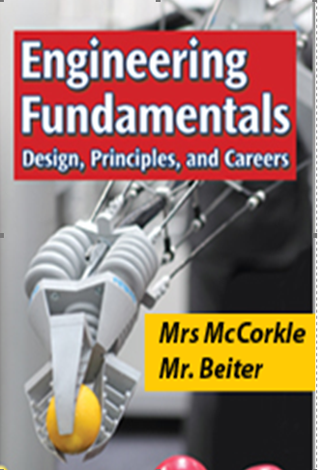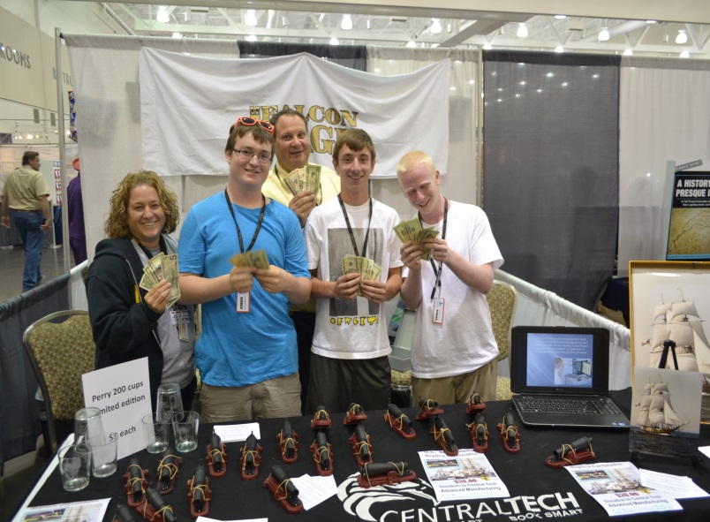

Contact Information
Mr. Beiter Email Mbeiter@eriesd.org Phone 814-874-6200 Ext 1557
http://www.eriesd.org/Page/5717
Mrs. McCorkle Email Mmccorkle@eriesd.org Phone 814-874-6200 Ext 1587
Mr. Wingerter Email MWingerter@eriesd.org Phone 814-874-6200

COURSE OBJECTIVES
- Students will develop an understanding of the core concepts of technology and design.
- Students will use engineering concepts of design and problem solving skills to develop products for manufacturing.
- Students will be able to write technical documents and build communication with professional personnel.
- Students will build desired skills in preparation for college and careers post graduation.

TOPICS
1st & 2nd Year | 3rd & 4th Year
Engineering Safety | Engineering Safety
Computer Aided Drawing | Computer Aided Drawing
Fields of Engineering | Engineering Systems
Design Process | Materials & Manufacturing Processes
Electrical Systems | Electrical Systems
Materials & Manufacturing Processes | Industrial Automation & Robotics
Hydraulics & Pneumatics | Thermal Systems

CAREER READINESS & SAFETY

- OSHA 10 Certification (Occupational Safety & Health Administration)
  - General Industry safety (MSDS, Slip and Fall, PPE, Blood Borne Pathogens)
  - http://www.careersafeonline.com/
- Tooling U Advanced Manufacturing and Engineering coursework.
  - http://www.toolingu.com
- Fanuc Robotics CERT
- http://www.Fanuc.com

CLASSROOM EXPECTATIONS
Students are expected to:
- Be prepared (textbook, pen/pencil, flash drive, completed assignments, and calculator, 3-ring binder).
- Complete class assignments and homework, maintain a notebook and prepare for assessments.
- Be on time for class and participate in class discussions and projects.
- Complete work missed during an absence.
- Follow school and district policies.
- Attend extra help when class material needs additional explanation.

MATERIALS
- Pen/pencil
- Steel Toed Shoes (for Welding/Machining Rotation)
- 3-Ring Binder w/ sheet protectors

ABSENCES
- Students are responsible for all work missed during an absence (this includes notes). Work missed due to an unexcused absence will receive a “0”. (Refer to the discipline policy.)

GRADING
- Quarter grades will be comprised of tests, class assignments, class notes, homework, clean up, projects, career & safety portfolio, Do Nows/bell ringers, and quizzes.
- Quarter grades will be determined by dividing the number of points earned by the number of points possible.
- The final grade is computed by averaging the percentages earned for each of the four quarters. (Note: An actual earned grade will be reflected on the report card.)

ERIE SCHOOL DISTRICT GRADING SCALE
A 90% - 100%
B 80% - 89%
C 70% - 79%
D 65% - 69%
F 0% - 64%

TESTS
- Tests are announced at least two classes in advance.

CLASS ASSIGNMENTS
- Class assignments are to be completed in class. Any assignment not completed in class will receive a “0”. Absent students must be “excused” to make up the missed work.
- Class assignments should include student’s name, date, and assignment.

PROJECTS
- All Projects will need to be completed by a desired deadline.
- Projects will be graded depending on the overall completeness and efforts towards the finished product.
- Any project unfinished by the deadline will result in a zero.

MANUFACTURING
- Students are responsible to acquire training on the various manufacturing equipment (CNC Router, Laser Engraver, 3D Printer) in the lab.
- Students will participate in engineering design reviews that will encompass the process as which a finished product will be manufactured
- Progress Reports
  - Students are to write in detail with complete sentences, using proper grammar, about the duties and activities the student performed for the week.
  - Students will be assessed on the detail of writing about their performance as well as the progress made in the classroom.
.

EXTRA HELP
- Extra help is available every morning and Wednesday 3:40PM . Additional times can be scheduled if necessary.

Classroom rules

- When i am talking you are not.
- Be cooperative and remain and task
- Demonstrate respect for yourself, fellow students, and property.
- You are to stay in seats unless directed otherwise
- All rules delineated in the 2023-2024 discipline handbook are in effect in this room.

LAB / SAFETY Rules

- No Horseplay, Running or wrestling in the lab
- Must complete Safety test prior to using any piece of equipment
- Use of appropriate ppe ie. Safety glasses are required
- Report any malfunctioning equipment or unsafe conditions to instructor immediately
- All rules delineated in the 2023-2024 discipline handbook are in effect in this lab

